Title: An exploration into the subject positionings of the female learning support assistant in post compulsory education, as they practice their art and craft.

Beverley Hayward
Birkbeck, University of London, UK

Introduction
This paper presents elements of a doctorate study that explores the subject positionings of a small group of women learning support assistants in post-compulsory education (known as LSAs). In this current landscape, policy changes in education have resulted in huge funding cuts to both further and higher education as well as those students with a disability. With this in mind, I may well have focused my study and this paper on the negative and constraining consequences of such changes, and rightly so, for the whole cohort of 122, at an arts university in which my study is contextualised, will be made redundant in July this year; already 43 have resigned. And therefore, you might be wondering why this was not my focus. I did not wish to tell a story that stresses the adverse positioning of the LSA. This is the stance already put forth in the limited literature of the past that discusses their dire working conditions. The themes are from the position of lack: lack of training and development; lack of resources and facilities; and lack of contractual security (Dyer, 1996; Barkham, 2008; Watson, et al 2013; Veck, 2009). In this position of lack, of not being good enough, there is an implication that they can be better. Therefore, their knowledge production is not privileged in the hierarchies of the academy, even though they are employed precisely for prior experience of being the good mother. According to Veck (2009: 43) the assumption is that the LSA bridges the learning deficit to reproduce ‘the Good Student, the able, efficient, obedient, industrious student, the student who ‘fits in’’. Rather I wish to tell a different story, one of celebration and transformation; the celebration of the women’s ability to push against power hierarchies at play in higher education, and in doing so they resist those practices and policies that appear to marginalise them in the academy.

Rationale: Why this Landscape; Why this Tale from the LSAs’ Creative Toolbox?
In taking up the subject position of historian, story teller, I am narrating the tales of the women LSAs, and to a degree my own position and practice as a former LSA. For this process I took note of Michel Foucault’s instruction. He urges authors to write of what is of interest to them, and not to study his own motivations and interests, instead we are to write our own genealogies, our own stories (Sawicki, 1991:15). In this research process it became apparent that the women share certain similarities: the LSA role was a second or third career for all, coming late to a career in education; for most the role was offered after taking up the position of student at The University. As mature students the women came late to study for a degree or access course in the creative arts, and now they are all practitioners of art and craft. My curiosity was ignited: why was this the case? Why those employment choices in the system and institution of education and why those topics of study at The University?

In part the Government practices and policies that focus on widening participation, disability and higher education have influenced the LSAs’ landscape at The University, their careers and the teaching and learning choices. Often these policies did and do intersect with the ‘protected characteristics’ as referred to in the Equality Act 2010. Many of which do apply to the participants and I, not only as formal mature students of The University, with a disability, but as learning support workers, supporting students with learning differences and disabilities. Therefore, the landscape is complex and problematic, for policies do divide and restrain, but simultaneously they have enabled and facilitated certain practices and celebratory positions of transformations in spaces of transgression.

Contextualising the LSA Landscape
Before discussing the positions of transformation, it is necessary to briefly consider the landscape of The University’s LSAs in the context of the current government funding for LSAs in higher education. As a tutor and disability advisor I am in a fortuitous and privileged position. In this space I was able to address the everyday experiences of this cohort of women LSAs before they are displaced. Their day to day facilitates their students’ learning as they support them in lectures, in the studio with practical tasks and many more activities. They are funded to support their allocated student and not the rest of the class. (When support is given to the whole class, it is often the job of a teaching assistant and usually a role associated with compulsory education). Therefore, in their role as LSA, having supported a diversity of degree courses, their knowledge is often on par with the academic tutor giving the lesson. Yet their positioning is not privileged and hence the imminent displacement.

This displacement is set in the context of the current neoliberal agenda that is shaping the policies and funding for disability in higher education. In this aggressive neoliberal landscape that is driving Government policy, the women whose tales I tell, will soon be absent from The University. This is because the current Government has implemented policies to completely cut the funding for the LSA role in higher education; now the onus is placed solely with all universities to fund the LSAs. With this in mind, the situation at this University is time sensitive, for very soon there will not be any of the LSAs left. Many have resigned already, including six of my participants, and the rest of the cohort of seventy LSAs, dyslexia tutors and learning mentors will be displaced in the summer.

Foucault’s Toolbox
In order to explore the complexities of their landscape, the study analysed the events, emotions and experiences of the women’s everyday in the space of higher education. To fully explore the language and practices of the LSAs’ landscapes and the subject positions they take up, I crafted a Foucauldian framework, through a feminist lens. By dipping into Foucault’s vast ‘toolbox’, I selected the tools of discourse analysis and genealogy (Foucault, 1974 in O’Farrell, 2005:50). In choosing these tools the aim was to trace the relations of power/knowledge that supports the truths of the current educational system. This is to understand the overlapping and multiple subject positionings the women take up, including that of the LSA. In a Foucauldian understanding of power/knowledge, power is produced through accepted forms of knowledge and truth. Foucault states that:

Truth is a thing of this world: it is produced only by virtue of multiple forms of constraint. And it induces regular effects of power. Each society has its regime of truth, its “general politics” of truth: that is, the types of discourse which it accepts and makes function as true; the mechanisms and instances which enable one to distinguish true and false statements, the means by which each is sanctioned; the techniques and procedures accorded value in the acquisition of truth; the status of those who are charged with saying what counts as true (Foucault, 1980:131).

In this paper those ‘truths’ that perpetuate particular discourses are those that advance patriarchy, neoliberalism and the perceived value(less) nature of the (dis)abled body and those LSAs that support them. Whilst power constraints in these discourses, power also enables. It ‘reaches into the very grain of individuals, touches their bodies and inserts itself into their actions and attitudes, their discourses, learning processes and everyday lives’ (Foucault, 1980:30). Power and knowledge are intertwined, so that knowledge gives credence to discourses and the practices and languages affecting the flow of power. In this way power and knowledge are linked to produce truths, objects and subjects. Foucault states:

We must cease once and for all to describe the effects of power in negative terms: it ‘excludes’, it ‘represses’, it ‘censors’, it ‘abstracts’, it ‘masks’, it ‘conceals’. In fact power produces; it produces reality; it produces domains of objects and rituals of truth. The individual and the knowledge that may be gained of him belong to this production (Foucault 1991:194).

This exploration of power/knowledge and the take up of certain subject positions is conducted to form ‘a history of the present’, to problematise a landscape that has been shaped by a prolonged and established silencing of women (Foucault, 1991). The study disrupts this practice by voicing their stories, their truths, and in this way, it is a space in which the female LSAs’ speech and practices of art, craft and education can be seen and heard.

Crafting a Methodology: theory and practice
These tools of discourse analysis and genealogy were used in tandem with Helen Cixous’s écriture feminine, that is feminine writing. Like Foucault’s call to write our own stories, Cixous (1975) goes further to specifically encourage women in the writing of their own texts: she states,

Woman must write her self: must write about women and bring women to writing, from which they have been driven away as violently as from bodies - for the same reasons, by the same law, with the same fatal goal. Woman must put herself into the text - as into the world and history - by her own movement. (1975:347).

Although Cixous concentrates on the field of literature, I am using the concept of écriture feminine in the broadest sense to include all media and arts and craft activities. With all the women actively practicing art and craft, this was an ideal medium in which to express their truths. In this way the women create a ‘text’, that is an artwork that expresses tales that have been historically repressed in patriarchy’s discourse. As the ‘writer’ I am supporting the creation of the co-construction of their stories; being in this position and space together, the ‘truths’ of their experiences are excavated as a new story of knowledge is produced. This, a feminine story, illustrates the women’s experiences in their ‘texts’; as the LSA is writing, creating ‘her self’ in the artworks
Cixous, 1975). Therefore, the choice of methods with which to write this story began with reflecting upon the traces of Foucault’s The Order of Things (1970). The order privileges the knowledge/power hierarchy of the masters of the arts, his-story, that is contextualised into an ontology of European patriarchy that marginalises women. Cixous (1986:69) considers this gendered position as women are: ‘pushed to the side of History and change, nullified, kept out of the way, on the edge of the stage, on the kitchen side, the bedside’.

Yet it was to the ‘kitchen side’ and ‘the bedside’ that I went to document the creation of their text and visualise their creative spaces (Cixous, 1986:69). By stepping outside the ‘machine’ of patriarchy’s discourse, and into the ‘spaces of femininity’, their homes, it allowed me to craft ‘the collection’ of data that was neither ‘mechanical’ nor ‘rigid’ (Pollock, 1992; Brinkmann, 2012:7). To this end, the ‘history’ I am writing brings to the fore the tales from the toolbox of a small cohort of eight women, nine including my own story. Therefore, by choosing these tools, synthesised with an auto/ethnographical approach, their tales are told. The co-construction of narrative interviews, together with their art and craft works and poetry, form the methodologies for data collection. Therefore, in ‘craft[ing]’ together theory, practice and method, those tales explore a celebratory positioning, and although our exit from the university is imminent, it is a space of transformation and positivity. For this paper I decided to focus the analysis on a short summary of the position of mother and the transformations facilitated by their roles as creative educational practitioners.

Analysis
The practices of education in the academy divide, segregate and exclude, and thereby other those bodies that are different, whilst simultaneously normalising certain bodies in culture and language (Foucault, 1991). Yet in a position of othering, this has produced differing and overlapping subject positions for the participants, that includes the poor, bad, (dis)abled and or resilient student; the educational practitioner; wife, partner, mother, daughter; artist, ‘creative’; and transgressor. As all the women are makers of art/craft it was interesting to see how their work embodies these subject positions, by complying with, and disrupting the University’s ‘regimes’ and ‘games of truth’ (Foucault, 1980). When asked with what roles they identified, none of them said LSA; instead they self-identified as ‘artist’ and ‘mother’. It is to the shaping of these subjectivities upon which this analysis draws. The identification was to the mother outside the classroom to care for their own children, not the LSA role that is recruited from the ‘mum’s army’ that is often put forth in the literature (Stevens, 2013).

The shaping of the mothering subjectivity is expressed in many images that illustrate this caring and nurturing role. For example, participant 2 crafted a blanket to give to her son, as he made his way to university. She said that she stitched this to work through her emotions of her son leaving. Participant three painted a portrait of her daughter with an octopus. She said that this is a metaphor of ‘nature’s most beautiful mother’, as she, the octopus, embraces her daughter. Therefore, as a community of artists over a ten-year period, we all had many conversations about our relationships, emotions and art, suggesting that out of our marginalised space at the back of the library, it was a landscape of healing, from, for example, traumatic schooling experiences and relationship break ups, facilitating transformations.

Thus, for this paper I decided to reflect upon how the University has been a cathartic space in which lifelong learning has made for transformations and reinventions. In this cathartic process it allowed us to ‘fly’ from patriarchy’s discourse, to a space of healing to write a story that is not part of neoliberalism’s marketisation and competing agenda (Cixous, 1975). It brings together educational practices, knowledges and truths that support the shaping of a creative and ethical subjectivity. Many of the participants experienced some very emotional and abusive educational experiences. They felt that in fostering an ethical and encouraging environment it was a way they could ‘give back’ to their students and themselves. In this way it is a stance that disrupts and problematises a neoliberal discourse. They subvert the discursive positionings, processes and practices of the constructions of the ‘poor’/bad student (Watson et al, 2013). This was once the subjectivity that shaped the ‘history of their past’ and the literature written about them, but not by them (Foucault, 1991).

No longer are they poor students, they are ‘resilient learners’ (Hoult, 2012). By drawing upon the work of Hoult (2012) to problematize this discourse of the poor student, it need not be read negatively as failing in education. Instead many of my participants have taken up the subject position of the ‘resilient learner’ as they returned to education as mature students. However, their resilience as learners is not an aspect upon which the literature focuses, instead it is the shaping of a subjectivity that is not ‘good enough’, a failure in compulsory education and by implication there is a need to make them a better resource as the LSA. However, these constructions of the student/learner, whether ‘good’, ‘bad’ or resistant is a fluid process, often overlapping.

In this fluidity of overlapping positions, including that of educational practitioner, space is created for opportunities to encourage each other and those they support. In this way they are able to pursue their creativity and artistic potential, in alternative spaces to the academy, in their studios, homes, and the local community. In this community of practice, they are considering the expectations and potential for themselves and their students in an ethical and holistic way. This subversive stance, of pushing against neoliberal and gendered discourses is the embodiment of past experiences that negated their own opportunities to pursue careers of their choice. Participant 3 eloquently makes this point when she explains that,

I am an LSA because I think that when I was young I was not encouraged to do my art; I was told by my parents that ‘Oh it’s too competitive, or you’re not that good.’ … so I found it a lot later in life. I think that’s why I wanted to go and help people who find themselves in the art arena. To encourage them to sort of have ownership of that.

This is the stance taken by the other participants, who were denied an artistic space in the academy and thereby othered into service industries. Here entry was restricted by those situated in a position of gatekeeper. For example, Participant 1 was told that art was not an option as it did not fit in with the rest of her timetable. I too found this was the case, art was not even an option at A Level for me. For Participant 3 there too was limited choice, due to gendered socialisations and the cultural value placed on certain knowledges. Accordingly, she started a linguistic degree with art history but did not complete, as it was not what she wanted to do:

I remember that there was a table with leaflets. I really wanted to go to arts school, but all the leaflets were pretty gendered really, as being at a convent. … I do remember having a big row with the parents, … I wanted to go to art school and the nuns had said that she is capable of more than that – make her go and do something else, and she can draw in her spare time.

Reflection
In a landscape where power/knowledge flowed to supress the artist, this cohort have used their tools from their toolbox. This has facilitated many artistic experiences, to transform, to become an artist, to be creative, both for themselves and their students alike. The research suggests that rather than being a landscape of negativity, redundancy has made space for the women to pursue opportunities outside the academy. This has made for communities of ethical practice, of caring for each other, learning from one another and their students. For what they learnt in the academy from a formal degree and informally supporting their students in many lessons has made for an ease of exit from the academy to progress to a new and exciting landscape. This transformation is expressed in the voice of an LSA, who wrote a poem for my study and upon which I shall end this paper. She says:

In essence you are already it,
I‘ll show you, in my own special way.
Equipping you with the tools that you’ll need to succeed.
Take them from me, they are a gift,
My pleasure, all yours.

Creativity flows through your veins
Don’t ever doubt it, believe in your abilities.
Be the very best that you can be
Never give up, I will not give up on you
All I ask is that you try.

Push past your boundaries,
Allow yourself to become inspired.
Focus, meditate and be driven,
by your own passion for life.

Do not sleep, wake up!
Your time is now,
To overcome your fears of failing,
You have the strategies, methods and techniques
All packed in your creative satchel.

Learn to know yourself well
Trust your own talents
To correct, design and remake
Mould yourself into being
Become the artist, change the world.
References
Barkham J (2008) ‘Suitable work for Women? Roles, relationships and changing identities of 'other adults' in the early years’ classroom’, British Educational Research Journal, 34, 6, pp.839-853.

Brinkman S (2012) Qualitative Inquiry in Everyday Life, London, Sage

Cixous H (1976) ‘The Laugh of the Medusa’, Signs, 1, 4, pp.875-893

Cixous, H., (1986). Newly Born Woman, USA, University of Minnesota Press

Dyer H (1996) ‘Where Do We Go From Here? Issues in the Professional Development of Learning Support Assistants, Research in Post-Compulsory Education, 1, 2, pp.187-198

Foucault M (1970) The Order of Things, NY, Pantheon Books

Foucault M (1974) in O’Farrell C (2005) Michel Foucault, USA, Sage

Foucault M (1980) ‘Truth and Power’ in C Gordon (ed) (1988) Power/knowledge. Selected Interviews & Other Writings by Michel Foucault, 1972-1977, Brighton, Havester

Foucault M (1991) Discipline and Punish: the birth of a prison, London, Penguin

Hoult E (2012) Adult Learning and la Recherche Féminine: Reading Resilience and Hélène Cixous, USA, Palgrave MacMillan

Pollock G (2003) Vision and Difference, London, Routledge

Sawicki J (1991) Discipling Foucault: feminism, power and the body, NY, Routledge

Stevens J (2013) ‘Army of teaching assistants faces the axe as Education department attempts to save some of the £4billion they cost each year’, Daily Mail, [online] http://www.dailymail.co.uk/news/article-2334853/ (Accessed 5/3/15)

Veck W (2009) ‘From an exclusionary to an inclusive understanding of educational difficulties and educational space: Implications for the Learning Support Assistant's role’, Oxford Review Education, 35, 1, pp.41-56

Watson DL Bayliss PD & Pratchett G (2013) ‘Pond life that 'know their place': exploring teaching and learning support assistants’ experiences through positioning

Presentation

My paper explored the subject positionings of the female, LSA, that is the learning support assistant in post compulsory education, as they practice their art and craft in the everyday. It explored the ways in which the uptake of multiple subject positionings, including that of LSA has facilitated transformations and reinventions. I am particularly interested in their experiences of what it is like to work in higher and further education, that is currently beset by a neoliberal agenda, which promotes an aggressive marketisation of education.

In these discourses of patriarchy and neoliberalism I used the theoretical framework of Michel Foucault, and certainly these are discourses in which the women are situated; however, there are creative moments and spaces that locates them outside of discourse. In these spaces of creativity, illustrated are the women’s experiences and this is transcribed in their ‘texts’. In this way the LSAs are writing, creating ‘her self’ in the artworks.

Being in such a privileged position the women described to me how they are able to transcend discourses to create, feminine stories. In the light of Cixous’s advice, I have tried not to over analyse, and not to interpret their experiences coloured by my own perspectives, realities and truths, and so it is to their words and texts that I draw upon for this presentation. Participant 1 eloquently explains the uptake of the subject position of transformation in the space of creativity. This is situated outside of discourses, enabling the use of the écriture feminine. She said:

Well I want to talk about my work, the first body of work, which was done in the last couple of years, where I was exploring abstract expressionism and the sublime. I’m quite interested in Marc Rothko and his paintings and the way he works. Mine are very intuitive paintings, they come from an experience and feeling, there is no plan in these painting they can start off if I’ve had a hot stone massage or if I’ve had a walk in the park, and then they just come from a feeling I’ve had that I just translate as in Tree of Truth.

In doing those, sometimes they come through directly as I feel the experience and I try to translate that into an image, whereas sometimes as in Plato’s Atlantis it begins as one thing and then it changes so it began as leaves blowing in the park, which I drew. Then it slowly changed and started to go into a portal and then I started discovering things about the things I was painting, so they are very unconscious thoughts coming through.

They are a body of work and this one here, that one with the red, I call Epiphany. And it’s that moment when everything makes sense, and everything just explodes in front of your eyes and you can see everything and it is bliss, and then with the green one.

This one is called Overflow, and this is just when the whole of nature is just saturating my entire being and just washing over you and washing everything, washing the negative away.

And then this one is called Beyond Space and Time, and this is just, well it just is what it’s called really. It just allows you to drift into a different space and time of meditation, where you get little sparks, little ideas, just little realisations that just becomes little thoughts of realisations, where you are having little conversations with yourself.

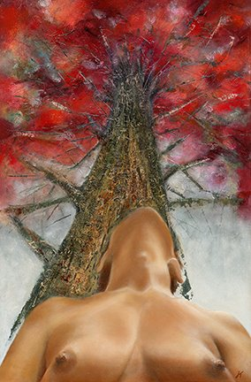

Diana, 2016, Tree of Truth, oil on canvas
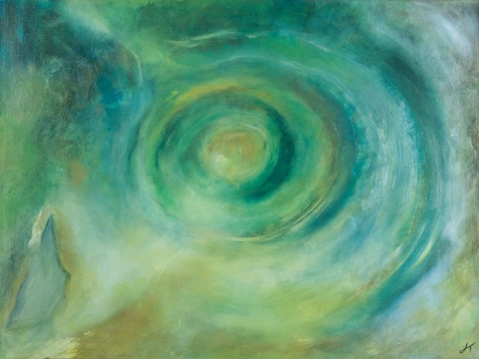

Diana, 2016 Plato’s Atlantis, acrylic on canvas

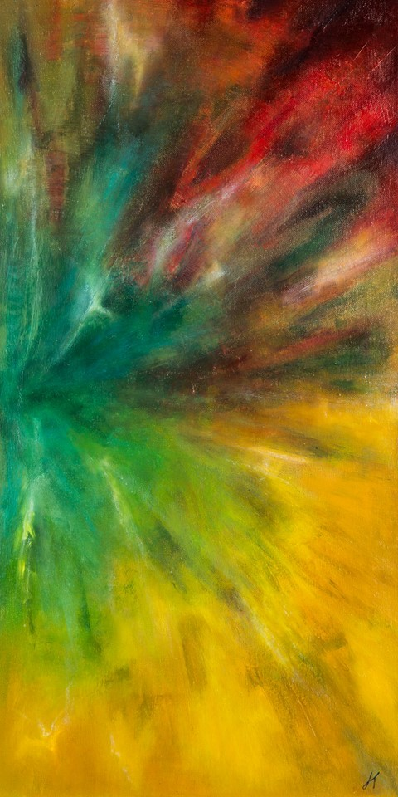

Diana, 2016, Epiphany, Oil on Canvas, 16" X 32"

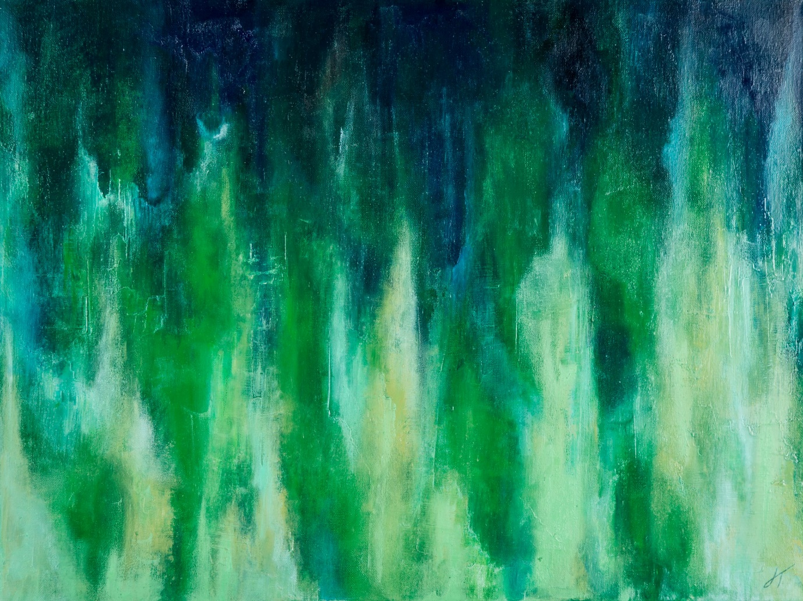

Diana, 2016, Overflow, oil on canvas, 12.0" x 16.0"

Many of my participants explained how the creative experience is one of self-expression, intuition, feelings, emotions and the unconscious. This process supports the ability to transform and reinvent. However, often these experiences oscillate with discourses in which they are positioned; they were fully aware of being positioned in these discourses and the complex spaces of home and work. Participant 2 illuminates upon the overlapping subjectivities that are shaping the uptake of the subject positions of artist, learner and teacher in the everyday. Those positions collide with mother, and LSA: she explains,

I sort of see myself as here in the home at the moment, and a parent and sort of his teacher, as there is a lot of teaching involved with a small child and a teenager, and you have to keep changing to keep up with it. And learning a few new tricks. So I do see that as one of my roles up ‘til now, as a home person, and a mother and a parent, and teacher. And, also in a role I see myself as a creator, as a maker.

If I’m sounding a bit pretentious, I’m not. I don’t know it just, well maybe I am. It’s just because, I see myself as an artist, well maybe an emerging artist: I see myself as a creator person. When I was leaving school, I did want to do art and I wasn’t allowed to. I would have liked to have done it. But then we wouldn’t be here now, we wouldn’t be having this nice conversation, and everything.

But I did want to do that and I always have been, all my life, I’ve made things. I can’t remember a time when I wasn’t playing with a bit of string, a bit of paper, a bit of fabric, a bit of clay. Always, always, always made something, all my life: so I see myself as a creative sort of person. I would say that they are the two main things in my life. They are quite good things and they are not exclusive, mutually exclusive, they can work together.

The balance is going to change that’s the only difference. You know, hopefully, may be, hopefully I will have more time for the creativity, because my son’s leaving, moving away and bit by bit letting him go, and that’s the thing. … when the opportunity to work in a creative environment came up I jumped at it. The timetable is reasonably flexible and allows me some time for designing/making. It is also good to have some financial independence - which I really missed when I gave up work to bring up my son! The environment was quite good; it’s interesting as you can pick up things and you can still learn.
For the project she was working on during the time that I conducted the interview she combined the subject positions of learner, maker, artist and mother. At this time, her son was off to uni. She said:

I thought I’m going to miss him: empty space. And so I thought I would start on a new project, and the new project was to make a nice big blanket, a bed blanket, a nice cover, a sort of warm, sort of wrap you up, so that I might give it to him for a present, or I might not; if it’s too nice, I’ll keep it for myself. It was sort of for me as a comfort kind of thing. So, basically, I called it Empty Nest Blanket. Because it was to give me something to do and it was a new project, to give me something to do. Something to just draw on, design, and start working on, to keep me busy. So I’ve came up with this pattern and started working on it

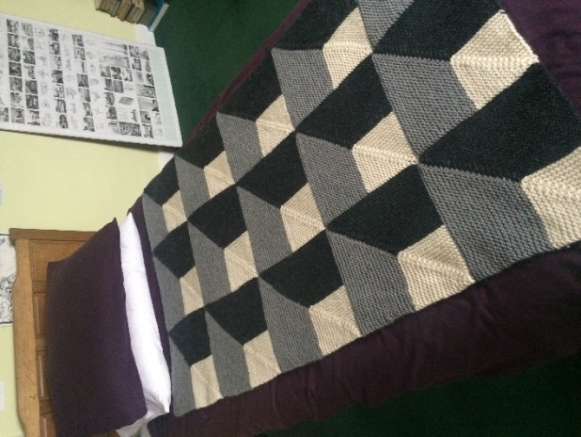
Eve, 2016 – present, Empty Nest Blanket, wool

Since, the time of the interview two years ago, her son has now completed his second year at medical school; she has built her studio in her garden and is becoming the artist. However, last month, when we met up to see the last of our cohort of students graduate, she said she still had two squares to knit. I said no matter, I still have my piece to complete as well. Participant 1 is also using all that she learnt in the everyday practices of the support worker and is teaching workshops in the community, creating a prolific body of work and selling them online.

Accordingly, my data that I collected partly disputes Dyer’s findings that I discussed in my paper. In her article, entitled ‘Where Do We Go From Here? Issues in the Professional Development of Learning Support Assistants’. Dyer suggested that for ‘some women, the choice of career as an LSA remains one of a committed location, whereas, for some men, it seems to fulfil a transitional role’ (192). Our participants were from differing subject positions. Her participant cohort were studying for a learning support qualification, whereas mine were graduates of the creative arts. So in a dialogue with Dyer, her question is a poignant one and one that I wish to respond. The committed location for my participants is one of a creative space, rather than the vocation space of support. So where do they go from here?

X 3 | Creative career – self employed
 | Unemployed; undecided
 | Caring for mother
 | Early Retirement – self-improvement
 | TA in compulsory education
 | Teacher of art in a prison
 | Career change on completion of Phd

With this is mind we were in the academy together as support workers and the ‘truths’ of their and my experiences are constructed as new bodies of knowledges produced in spaces of creativity and transformation. As the ‘writer’ of this story I am facilitating the creation of the écriture feminine, as I collage their stories. And in Cixous’s spirit of writing the feminine I end on a poem created by one of the LSAs just before we exited from the academy. It is entitled:

Begin Again

Stay if you’ll let me,
hold on if you’ll have me.
Just one last minute,
so I never let go

Cradle, rock, carry me,
never to be free.
Nurture, love, then betray me,
till my grip loosens its hold.

Falling…
suddenly I find.
I move through fear
to peace of mind.
Landing…
two firm feet.
The future, my gaze.
a vision complete.

Wings outstretched,
perspectives change,
life turns over a different page.
I write the stories now.

The end is where it begins again.

